AUTOMATIC ATTENDANCE SYSTEM USING

QR TECHNOLOGY

Automatic Attendance System Using QR Technology Project submitted to the

Department of Computer Science and Engineering, Hajee Mohammad Danesh Science and Technology University in partial fulfillment of the requirements for the degree of

B.Sc. (Engineering) in Computer Science and Engineering

By

Riduwoanul Hasan Parvez

Student ID: 1902041

Session: 2019

Md. Sabbir Hosen

Student ID: 1902040

Session: 2019

Mst Sathi Akter

Student ID: 19020

Session: 2019

Subroto Kumar Gun Opu

Student ID:1902022

Session: 2019

Supervised by

Dr. Md. Abdulla Al Mamun

Professor



DEPARTMENT OF COMPUTER SCIENCE AND ENGINEERING

HAJEE MOHAMMAD DANESH SCIENCE AND TECHNOLOGY UNIVERSITY, DINAJPUR-5200, BANGLADESH

February 2024



**DECLARATION**

The work entitled **“"Automatic Attendance System Using QR Technology"”** has been carried out in the Department of Computer Science and Engineering, Hajee Mohammad Danesh Science and Technology University is original and conforms to the regulations of this University.

We understand the University’s policy on plagiarism and declare that no part of this project has been copied from other sources or been previously submitted elsewhere for the award of any degree or diploma.

……………

(Riduwoanul Hasan Parvez)

Studet ID: 1902041

Session: 2019

……………

(Md. Sabbir Hosen)

Student ID: 1902040

Session: 2019

……………

(Mst.Sathi Akter)

Student ID:

Session: 2019

……………

(Subroto Kumar Gun Opu)

Student ID: 1902022

Session: 2019

**Acknowledgement**

We express our sincere appreciation to all individuals and entities who contributed to the successful completion of this project, "Web-Based Attendance System using QR Code Technology."

First and foremost, we extend our gratitude to our supervisor, Professor. Dr. Md. Abdulla Al Mamun, whose guidance, expertise, and support were invaluable throughout every stage of the project. His insightful feedback and encouragement greatly enriched our understanding and implementation of the system.

We also acknowledge the significant contributions of our co-supervisor, Professor. Adiba Mahjabin Nitu, whose expertise and assistance played a crucial role in shaping the project's direction and ensuring its success.

Furthermore, we would like to thank the students who participated in testing the system and providing valuable feedback. Their input was essential in refining the system's usability and functionality.

We are grateful to our institution for providing the necessary resources and facilities for the development of the web-based attendance system. Without their support, this project would not have been possible.

Lastly, we extend our appreciation to all our friends, family, and colleagues who supported us throughout the project with their encouragement and understanding.

In conclusion, we acknowledge the collective effort and support of everyone involved, without which this project would not have been accomplished.

# **Contents**

**Declaration i**

**Acknowledgement ii**

**Contents iii**

**List of Figures iv**

**Abstract v**

**1 Introduction**

1.1 Background and Motivation

1.2 Objective

1.3 Goal Of This Project

1.4 Scope

1.5 Methodology

1.6 Organization of the Report

**2 BACKGROUND ANALYSIS**

2.1 Introduction

2.2 Evolution of Attendance Giving & Tracking Methods

2.3 Introduction to QR Technology

2.4 Applications of QR Technology in Attendance Tracking

2.5 Current State of Attendance Systems

2.6 User Experience Analysis

2.7 Legal and Ethical Considerations

**3 SYSTEM ANALYSIS & REQUIREMENT SPECIFICATION**

3.1 Introduction

3.2 Current System Analysis

3.3 User Requirements

3.4 Functional Requirements

3.5 Non-functional Requirements

3.6 Hardware and Software Requirements

**4 SYSTEM ARCHITECTURE**

4.1 Use Case Modeling

4.2 Context Diagram

4.3 E-R diagram

**5 DESIGN SPECIFICATION**

5.1 Technology Stack

5.2 System Components

5.2.1 Snapshot Of System

5.2.2 Snapshot of manage Database

**6 IMPLEMENTATION & TESTING**

6.1 Database Setup

6.2 Frontend Development

6.3 Backend Development

6.4 Testing Implementation

6.4.1 Unit Testing

6.4.2 Integration Testing

6.4.3 User Testing

**7 CONCLUSION AND FUTURE SCOPE**

7.1 Achievements

7.2 Future Enhancements

**REFERENCE**

# **List of Figures**

**FIGURES PAGE NO**

**Figure 4.1.1 :** Use Case Diagram of Seller

**Figure 4.2.2 :** Level-0 Context Diagram

**Figure 4.2.3 :** Level-1 Context Diagram

**Figure 4.2.4 :** Level-2 Context Diagram

**Figure 4.2.5 :** Entity-Relationship Diagram

**Figure 5.1.1 :** Home Page

**Figure 5.1.2 :** Login Page

**Figure 5.1.3 :** Course List For Student

**Figure 5.1.4 :** Class list For Student

**Figure 5.1.5 :** Attendance List For Student

**Figure 5.1.6 :** Course List For Teacher

**Figure 5.1.7 :** Class List For Teacher

**Figure 5.1.8 :** Qr Scanner Page For Teacher

**Figure 5.1.9 :** Courses Collection Of MongoDB

**Figure 5.1.10:** Classes Collection Of MongoDB

**Figure 5.1.11:** Students Collection Of MongoDB

**Abstract**

The "Web-Based Attendance System using QR Code Technology" project introduces a novel approach to attendance management in educational institutions. Leveraging QR code technology, the system offers a streamlined and secure method for students to Mark their attendance, thereby mitigating the risks associated with proxy attendance. Under the guidance of Professor Dr. Md. Abdulla Al Mamun and Professor Adiba Mahjabin Nitu, the project team embarked on a journey to develop a cutting-edge solution that addresses the challenges prevalent in traditional attendance tracking systems.

The system's architecture integrates seamlessly with existing institutional frameworks, providing Teachers with real-time attendance data and analytics. Through a user-friendly interface, students can effortlessly scan QR scanner displayed in classrooms or lecture hall to register their attendance. This innovative approach not only enhances the accuracy and reliability of attendance records but also promotes accountability and transparency within educational settings.

Throughout the project's lifecycle, rigorous testing and iterative refinement were employed to ensure the system's robustness and efficacy. The resulting solution represents a significant advancement in attendance management practices, promising to revolutionize the way educational institutions track and monitor student attendance.

In this report, we document the conceptualization, development, and implementation of the web-based attendance system, offering insights into its technological underpinnings and pedagogical implications. By presenting a comprehensive overview of our methodology, findings, and future directions, we aim to inspire further innovation in the field of educational technology and contribute to the advancement of attendance tracking solutions.

**Chapter One**

**Introduction**

* 1. **Introduction**

In an era where technological advancements redefine the landscape of education, the quest for efficient attendance tracking systems remains perennial. In response to this need, our project, titled "Web-Based Attendance System using QR Code Technology," emerges as a beacon of innovation and reliability. With a focus on mitigating proxy attendance, enhancing user experience, and ensuring data accuracy, our endeavor seeks to revolutionize traditional attendance management practices.

Under the astute guidance of Professor Dr. Md. Abdulla Al Mamun and the adept supervision of Professor Adiba Mahjabin Nitu, our team embarked on a journey to develop a cutting-edge solution tailored to the needs of modern educational institutions. By harnessing the power of QR code technology, our system offers a seamless and secure method for students to mark their attendance with unparalleled ease and accuracy.

This report encapsulates the meticulous process of conceptualization, development, and implementation that underpins our innovative solution. Through comprehensive analysis, rigorous testing, and iterative refinement, we have strived to deliver a product that not only meets but exceeds the expectations of stakeholders.

As we delve deeper into the intricacies of our web-based attendance system, we invite readers to embark on a journey of discovery, innovation, and transformation. Together, let us explore the technological marvels and pedagogical implications of our pioneering endeavor, poised to reshape the landscape of attendance management in educational institutions.

* 1. **Background And Motivation**

In contemporary educational environments, the traditional methods of attendance tracking often fall short in terms of efficiency, accuracy, and security. Manual attendance taking, prone to errors and subjectivity, poses significant challenges for institutions striving for accountability and transparency. Moreover, the prevalence of proxy attendance undermines the integrity of academic records, exacerbating the need for innovative solutions to address these issues.

Recognizing these challenges, our project, "Web-Based Attendance System using QR Code Technology," was conceived with a primary objective: to revolutionize attendance management practices in educational institutions. By harnessing the power of QR code technology, we sought to develop a system that not only automates the attendance giving process but also enhances its reliability and security.

The motivation behind this project stems from a desire to leverage technology to streamline administrative tasks, empower educators, and foster a culture of accountability among students. By implementing a web-based solution that integrates seamlessly with existing institutional frameworks, we aimed to provide administrators with real-time access to attendance data, enabling informed decision-making and resource allocation.

Furthermore, the prevalence of proxy attendance, fueled by outdated or ineffective attendance tracking methods, served as a catalyst for our innovation. We were driven by a vision to develop a system that not only eliminates the possibility of proxy attendance but also promotes student engagement and participation through user-friendly interfaces and intuitive processes.

In essence, the background and motivation of this project lie in the convergence of technological advancements, institutional challenges, and the quest for academic integrity. By addressing the shortcomings of traditional attendance management practices, we aspire to contribute to the enhancement of educational experiences and the cultivation of a culture of excellence within educational institutions.

* 1. **Objective**

The objectives of the "Web-Based Attendance System using QR Code Technology" project are delineated as follows:

1. **Proxy Attendance Mitigation:** The primary aim is to develop a system that effectively mitigates proxy attendance through the utilization of QR code technology. By authenticating students' presence via scanning QR codes, the system will ensure the integrity and accuracy of attendance records.

2. **User Experience Enhancement:** An essential objective is to prioritize user experience for both students and teachers. The system will feature an intuitive, user-friendly interface to simplify attendance marking for students and provide administrators with efficient tools for managing attendance data.

3. **Administrative Efficiency Improvement:** The project endeavors to streamline administrative tasks associated with attendance tracking. Through automation of the attendance recording process, administrative workload will be reduced, errors minimized, and real-time access to attendance data facilitated for administrators.a

4. **Accountability Promotion:** A fundamental goal is to foster a culture of accountability among students. Transparent and accessible attendance records will be made available, encouraging students to take ownership of their attendance and instilling a sense of responsibility within the academic community.

5. **Integration with Existing Systems:** The project aims to ensure seamless integration of the new system with existing institutional frameworks. Compatibility with various educational systems and structures will be prioritized to facilitate easy adoption and implementation across different educational institutions.

Through the attainment of these objectives, the project endeavors to revolutionize attendance management practices in educational institutions. By leveraging QR code technology and emphasizing user experience, efficiency, and accountability, the project seeks to contribute significantly to the enhancement of administrative processes and the overall educational experience.

**1.4 Goal Of This Project**

The main goal of this project is to create a QR-based attendance management system for academic institutions, enabling teachers to efficiently track attendance by utilizing a camera interface for students to scan their unique QR codes. Traditional attendance methods often involve manual processes that are time-consuming and error-prone. By integrating QR code technology with a camera interface, this project aims to simplify the attendance-taking process, providing a seamless solution for both teachers and students.

Teachers will open the camera interface within the system, projecting it onto a screen or visible to students. Each student will possess a unique QR code associated with their student ID. By presenting their QR codes to the camera interface, students can swiftly register their attendance without requiring additional login credentials or complex check-in procedures. This method ensures a smooth and efficient attendance recording process, allowing students to focus on their studies.

The system's backend will securely store attendance records to ensure data integrity and facilitate efficient record-keeping. Teachers will have access to real-time attendance tracking and receive notifications for any irregularities. Security measures will be implemented to protect student information and comply with data protection regulations, ensuring the confidentiality and integrity of attendance records.

In summary, the main goal of this project is to modernize attendance tracking in academic institutions by leveraging QR code technology and camera interfaces. By providing a user-friendly, efficient, and secure solution, the system aims to streamline administrative tasks, enhance data accuracy, and improve the overall educational experience. Through careful design and implementation, this project seeks to set a new standard for attendance management, promoting efficiency, innovation, and convenience in educational technology.

* 1. **Scope Of This Project**

The scope of this automated QR-based attendance management system encompasses several key aspects aimed at enhancing the efficiency and effectiveness of attendance tracking in academic institutions.

Firstly, the system will enable teachers to easily initiate attendance sessions by prompting students to scan their unique QR codes using a camera interface. This feature eliminates the need for manual attendance-taking methods and provides a streamlined process for both teachers and students.

Secondly, the system will facilitate seamless integration with existing academic infrastructure, allowing for smooth implementation across various departments and courses within the institution. This ensures scalability and adaptability to the specific needs of different academic settings.

Thirdly, the system will include robust backend functionality for securely storing attendance records and managing data. Teachers will have access to real-time attendance tracking and reporting features, enabling them to monitor student attendance patterns and identify any irregularities promptly.

Additionally, the system will prioritize user-friendly interfaces for both teachers and students, ensuring ease of use and accessibility. Students will be able to quickly scan their QR codes without the need for additional authentication steps, while teachers will have intuitive tools for managing attendance sessions and reviewing attendance data.

Furthermore, the scope of the system extends to comprehensive security measures to protect student information and ensure compliance with data protection regulations. This includes encryption protocols, access controls, and regular security audits to safeguard sensitive data.

Overall, the scope of this automated QR-based attendance management system encompasses a comprehensive solution for improving attendance tracking processes in academic institutions. By addressing key challenges and leveraging modern technology, the system aims to enhance efficiency, accuracy, and convenience in managing student attendance, ultimately contributing to an improved educational experience.

**1.6 Methodology**

**1.** **Requirements Gathering:**

* Conduct interviews with teachers and students to understand their needs and preferences regarding attendance tracking.
* Identify key features and functionalities required for the new system based on feedback from teachers and students.
* Analyze existing attendance management systems used by teachers and students to identify pain points and areas for improvement.

**2.** **System Design:**

* Develop a system architecture outlining the components and their interactions based on the requirements gathered from interviews.
* Design user interfaces for teachers and students, ensuring ease of use and accessibility based on their feedback.
* Define the database schema to efficiently store attendance records and manage data integrity, taking into account the specific needs of teachers and students.

**3.** **Technology Selection:**

* Choose appropriate technologies for frontend and backend development based on the project requirements and technical feasibility.
* Consider factors such as scalability, security, and compatibility with existing infrastructure when selecting technologies.

**4.** **Development:**

* Implement frontend interfaces for teachers and students using React.js, Daisy UI, Tailwind CSS, HTML, CSS, and JavaScript.
* Develop backend logic for user authentication, QR code generation, attendance recording, and data retrieval using Node.js and Express.js.
* Integrate MongoDB as the database management system to store attendance records securely.

**5.** **Testing:**

* Develop unit tests and integration tests for both frontend and backend components to ensure functionality, reliability, and performance.
* Conduct user acceptance testing (UAT) with teachers and students to validate the usability and effectiveness of the system.
* Address any issues or bugs identified during testing and make necessary adjustments to improve the user experience.

**6.** **Deployment:**

* Deploy the system to a staging environment for final testing and validation.
* Prepare documentation including installation instructions, user manuals, and troubleshooting guides for teachers and students.
* Deploy the system to the production environment, ensuring scalability, reliability, and security measures are in place.

**7.** **Training and Support:**

* Provide training sessions for teachers and students on how to use the system effectively.
* Offer ongoing technical support and assistance to address any questions or concerns raised during deployment and operation.

**8.** **Evaluation:**

* Evaluate the effectiveness of the system in meeting the project objectives based on feedback from teachers and students.
* Gather feedback through interviews or surveys to identify areas for improvement and future enhancements.

**Chapter Two**

**BACKGROUND ANALYSIS**

* 1. **Introduction**

The process of attendance tracking in academic institutions plays a pivotal role in monitoring student participation and engagement. Traditional methods, predominantly reliant on manual processes such as paper-based sign-in sheets or physical attendance registers, often prove to be laborious, time-consuming, and susceptible to errors. Additionally, these methods pose challenges in terms of data management and accessibility, especially in larger educational settings.

In response to these challenges, there is a growing demand for modern, automated solutions that streamline the attendance tracking process while enhancing accuracy and efficiency. Leveraging advancements in technology, particularly QR code technology, presents a promising opportunity to address these needs effectively. QR codes offer a convenient and reliable means of marking attendance, allowing students to simply scan a code to register their presence in class.

By conducting a comprehensive background analysis, this project aims to explore the current landscape of attendance management systems in academic institutions, identifying their limitations and areas for improvement. By understanding the needs and preferences of teachers and students through interviews and surveys, we can design and develop a tailored solution that leverages QR code technology to revolutionize the attendance tracking process, ultimately enhancing the educational experience for all stakeholders.

* 1. **Evolution of Attendance Giving & Tracking Methods**

Attendance tracking in academic institutions has evolved significantly over the years, reflecting advancements in technology and changing educational practices. This section provides an overview of the historical progression of attendance giving and tracking methods:

**1. Manual Methods:**

* In the early days of education, attendance was recorded manually using paper-based methods such as sign-in sheets or attendance registers.
* Teachers would manually mark each student's presence or absence, often leading to errors and inefficiencies in data management.

**2. Roll Call:**

* Roll call became a common practice, where teachers would call out each student's name, and students would respond with "present" or "absent."
* While roll call provided a systematic approach to attendance tracking, it was time-consuming and prone to inaccuracies.

**3. Barcode and Magnetic Stripe Cards:**

* With the advent of technology, barcode and magnetic stripe cards were introduced for attendance tracking.
* Students were issued cards with unique identifiers encoded in barcodes or magnetic stripes, which they would swipe or scan to mark their attendance.

**4. Biometric Systems:**

* Biometric attendance systems emerged as a more secure and efficient method, utilizing fingerprint or facial recognition technology to verify students' identities.
* These systems offered faster and more accurate attendance tracking, but implementation costs and privacy concerns limited their widespread adoption.

**5. RFID and NFC Technology:**

* Radio-frequency identification (RFID) and near-field communication (NFC) technology enabled passive attendance tracking using RFID tags or NFC-enabled devices.
* Students' attendance could be automatically recorded as they passed through RFID or NFC checkpoints, reducing manual intervention and improving accuracy.

**6. QR Code Technology:**

* QR code technology has emerged as a versatile and cost-effective solution for attendance tracking in recent years.
* Students are provided with QR codes linked to their unique identifiers, which they can scan using mobile devices or dedicated scanners to mark their attendance quickly and conveniently.

**7. Integration with Digital Platforms:**

* Attendance tracking systems are increasingly being integrated with digital platforms such as learning management systems (LMS) or mobile applications.
* This integration allows for seamless data management, real-time tracking, and enhanced communication between teachers, students, and administrators.

In summary, the evolution of attendance giving and tracking methods has transitioned from manual processes to sophisticated technological solutions like QR code technology. These advancements have not only improved efficiency and accuracy but also transformed the way attendance is managed in modern educational settings.

* 1. **Introduction to QR Technology**

Quick Response (QR) codes have revolutionized data encoding and retrieval processes with their ability to store information in a two-dimensional format. Initially developed by Denso Wave in 1994 for tracking automotive parts, QR codes have since found widespread use in various industries, including marketing, logistics, and education.

QR codes encode data such as URLs, text, or contact information, which can be scanned and read by smartphones, tablets, or dedicated QR code scanners.Their versatility and ease of use have made them an integral part of modern technology, enabling seamless interactions between physical and digital environments.

In education, QR technology has gained popularity for its applications in attendance tracking, resource sharing, and interactive learning experiences. By simply scanning a QR code, students can access course materials, participate in quizzes, or mark their attendance, enhancing engagement and efficiency in educational settings.

* 1. **Applications of QR Technology in Attendance Tracking**

QR technology offers numerous advantages for attendance tracking in educational

settings. Firstly, it provides a convenient and efficient method for students to mark their

attendance by simply scanning a QR code using their smartphones or tablets. This eliminates the

need for manual sign-in sheets or cumbersome check-in procedures.

Additionally, QR codes can be easily generated and distributed by teachers for each class session, reducing administrative burden and streamlining the attendance-taking process. The unique codes can include student IDs or other relevant information, ensuring accurate recording of attendance data.

* 1. **Current State of Attendance System**

Currently, two prevalent methods of attendance tracking include roll call and signing attendance sheets. Roll call involves teachers calling out student names, with students responding to indicate their presence. This method is labor-intensive and prone to errors. Alternatively, students physically sign attendance sheets upon entering class, verifying their attendance. However, this method can also be time-consuming and may lead to inaccuracies, particularly if students sign on behalf of absent peers. Both methods rely on manual processes and lack the efficiency and accuracy offered by modern digital attendance tracking solutions like QR technology.

* 1. **User Experience Analysis**

The user experience (UX) analysis focuses on evaluating the effectiveness and usability of the attendance tracking system for teachers and students.

**1. Interface Evaluation:**

* Assess the clarity, simplicity, and intuitiveness of the user interfaces.
* Consider layout, navigation, and visual design for a seamless experience.
* Ensure accessibility across different devices.

**2. Functionality Testing:**

* + Test key features like QR code generation, scanning, and attendance recording.
  + Evaluate responsiveness and reliability in real-world scenarios.
  + Identify and prioritize bug fixes.

**3. User Satisfaction Surveys:**

* Conduct surveys to gather feedback on ease of use and usefulness.
* Analyze data to identify common pain points and areas for improvement.

**4. Iterative Design:**

* Implement user feedback to enhance usability and satisfaction.
* Continuously monitor user engagement for ongoing improvement.

This analysis informs iterative design changes to optimize usability, efficiency, and overall satisfaction with the system.

* 1. **Legal and Ethical Considerations:**

**1. Data Privacy:** Comply with ensuring secure storage and processing of attendance data with explicit consent from students.

**2. Security Measures:** Implement encryption, access controls, and regular security audits to protect against unauthorized access and data breaches.

**3. Accessibility:** Design the system to be accessible for all users, adhering to WCAG standards and compatibility with assistive technologies.

**4. Consent and Transparency:** Clearly communicate data usage, obtain informed consent, and provide opt-out options for students.

**5. Anti-discrimination:** Ensure attendance policies do not discriminate based on protected characteristics and maintain fairness in practices.

**6. Ethical Data Use:** Use attendance data responsibly, avoiding misuse and upholding ethical standards in research and practice.

**Chapter Three**

**SYSTEM ANALYSIS & REQUIREMENT SPECIFICATION**

* 1. **Introduction**

In the development of our attendance management system project, system analysis and requirement specification are pivotal phases. These stages involve understanding stakeholder needs, defining system requirements, and documenting specifications to guide development.

Our project aims to modernize attendance tracking in educational institutions using QR code technology. Through interviews and surveys with teachers, students, and administrators, we'll gather requirements to ensure the system meets their needs efficiently.

System analysis will assess current attendance methods and challenges. Requirement specification will document gathered requirements concisely, serving as a blueprint for development.

By conducting thorough system analysis and requirement specification, we'll align the project closely with stakeholder goals, enabling efficient development and deployment while minimizing risks.

* 1. **Current System Analysis**

**1. Manual Processes:**

* The current attendance system relies on manual processes, such as roll call or sign-in sheets, for tracking student attendance.
* Teachers manually call out names or students physically sign attendance sheets to mark their presence in class.

**2. Time-Consuming:**

* Manual attendance tracking is time-consuming and can be inefficient, especially in large classes or institutions.
* Teachers spend valuable instructional time on attendance-taking, which could be utilized for teaching activities.

**3. Error-Prone:**

* Manual processes are prone to errors such as misinterpretation of handwriting, data entry mistakes, or duplicate entries.
* These errors can lead to inaccuracies in attendance records and affect the reliability of attendance data.

**4. Lack of Real-Time Tracking:**

* There is no mechanism for real-time tracking of attendance, making it difficult for teachers to monitor student participation during class sessions.
* Absenteeism or tardiness may go unnoticed until attendance records are manually processed and reviewed later.

**5. Limited Accessibility:**

* Accessibility to attendance records may be limited, with records stored in physical formats or inaccessible systems.
* Students may face challenges accessing their attendance records or tracking their attendance history, impacting their ability to monitor their progress.

**6. Compliance and Reporting:**

* There may be challenges in ensuring compliance with institutional policies or regulatory requirements related to attendance tracking and reporting.
* Manual systems may lack the necessary features or controls to facilitate accurate reporting and compliance with relevant regulations.

**7. Opportunities for Improvement:**

* Integration of automated attendance tracking solutions, such as QR code technology, can enhance accuracy, efficiency, and accessibility.
* Automation can streamline the attendance-taking process, reduce administrative burden, and provide real-time insights into student attendance patterns.

By analyzing the current system, we can identify areas for improvement and opportunities to enhance the efficiency and effectiveness of the attendance management process. Automated solutions offer the potential to address the limitations of manual processes and improve overall workflow and accountability.

* 1. **User Requirements**

**1. Teacher:**

* Camera functionality: Teachers should be able to access the camera within the system interface to verify attendance.
* Real-time tracking: The system should update attendance records instantly as students are verified through the camera.
* Flexibility: Teachers should have the option to choose QR code scanner for attendance verification, based on their preference and classroom setup.

**2. Student:**

* **Camera access:** Students should be able to access the camera within the system interface for attendance verification.
* **QR code:** Students should be able to scan QR codes through the camera to mark attendance.
* **Ease of use:** The attendance verification process should be straightforward and user-friendly for students, requiring minimal effort or technical knowledge.

These user requirements focus on providing a seamless and efficient attendance verification process for both teachers and students, leveraging camera functionality within the system interface. By addressing the needs and preferences of these primary users, the automated attendance system can enhance accuracy, efficiency, and user satisfaction in tracking attendance.

* 1. **Functional Requirements**

**1. QR Code Generation:**

* Generate unique QR codes for each student.

**2. QR Code Scanning:**

* Students should be able to scan QR codes using their smartphones or tablets to mark their attendance.

**3. Attendance Recording:**

* The system should record attendance in real-time as students scan the QR codes.

**4. Attendance Tracking:**

* Teachers should be able to view and track attendance records for each class session.
  1. **Non Functional Requirements**

**1. Performance:**

* Ensure efficient handling of attendance scanning requests during peak periods.
* Responsive system with minimal latency.

**2. Security:**

* Secured data during transmission and storage.
* Restrict access to authorized users with robust authentication.

**3. Reliability:**

* High system availability during scheduled class sessions.
* Accurate and reliable attendance recording without data loss.

**4. Usability:**

* Intuitive user interface for easy navigation.
* Simple QR code scanning process for students.

**5. Scalability:**

* Ability to accommodate a growing user base and class sessions.
* Scalable infrastructure to support varying institutional sizes.

**6. Computability:**

* Support for diverse devices and operating systems.
* Compatibility with popular web browsers and mobile platforms.
  1. **Hardware And Software Requirements**

**Hardware Requirements:**

• Storage: Minimum 1.5GB Storage.

• Ram: 4GB.

• Laptop, Desktop, Mobile

**Software Requirement:**

• Language: ReactJS, JavaScript

• For Design: HTML, Tailwind CSS, DaisyUI

• Database: MongoDB, NodeJs, ExpressJs

• Platform: Visual Studio Code

• Operating System: Windows, Linux.Android

**Chapter Four**

**SYSTEM ANALYSIS & REQUIREMENT SPECIFICATION**

**4.1 USE CASE MODELING**

A user case model describes different types of users interacts and their activities into a system. It is also a list of action which done by the user. The number of elements like as: An actor, an event, a use case. The major component is the actor. we have one in my projects, they are:

**• Teacher**

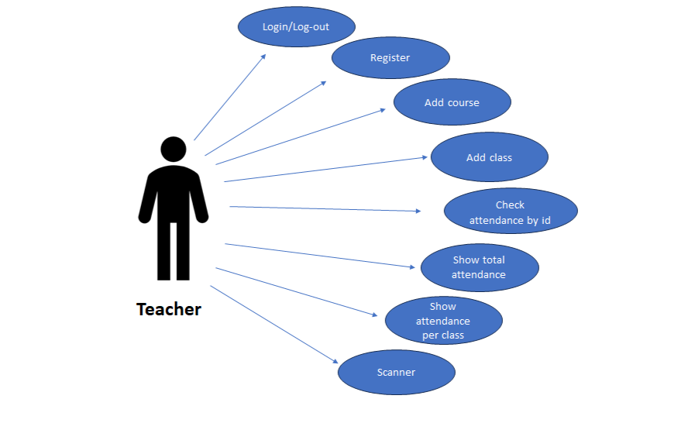

Figure 4.1.1: Use Case Diagram

**4.2 Context Diagram**

A Context Diagram is the highest level of data flow diagram. It represents the flows of information between the system and all external entities that may have interact with a system. The entire software system is shown as a single process.

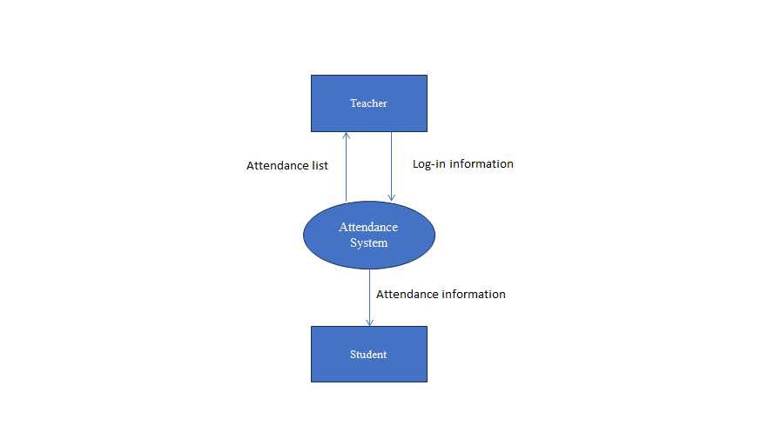 Figure 4.2.2: Level-0 Context Diagram of ‘Attendance System’

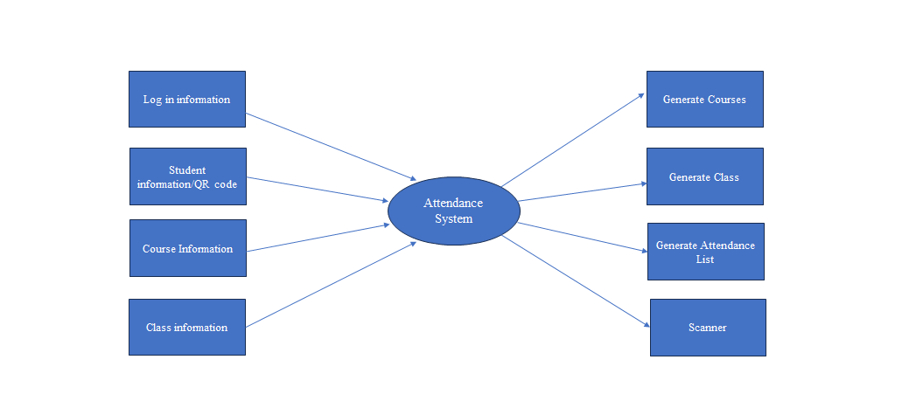

Figure 4.2.3: Level-1 Context Diagram of ‘Attendance System’

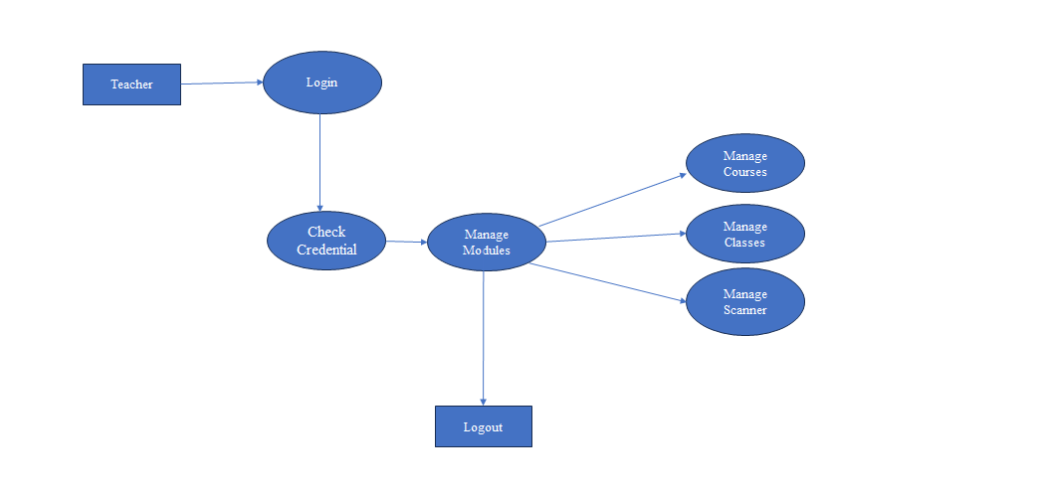

Figure 4.2.4: Level-2 Context Diagram of ‘Attendance System’

**4.3 ER Diagram**

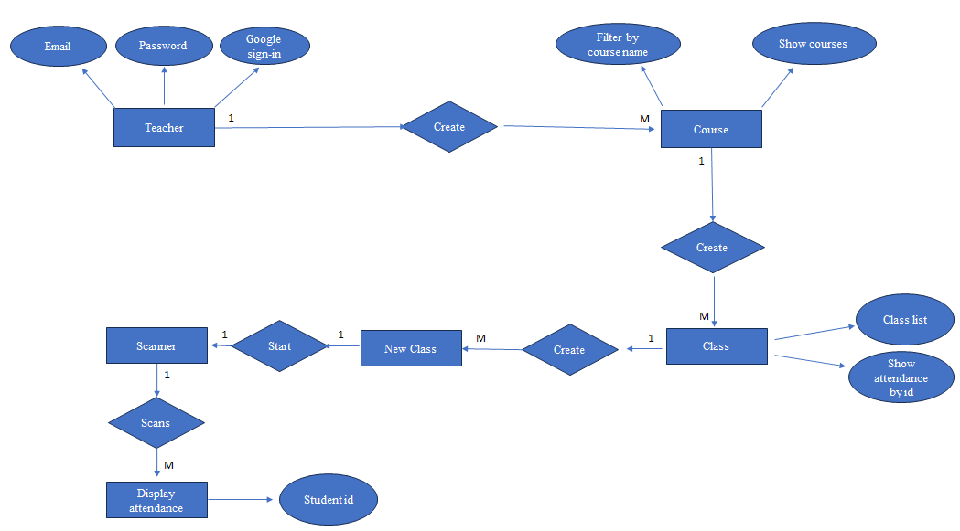

Figure 4.2.5: Entity-Relationship Diagram

**Chapter 5**

**DESIGN SPECIFICATION**

**5.1 Technology Stack:**

For your project, which involves building a web application with the functionality described earlier (including QR code scanning, class creation, attendance tracking, etc.), here's a suggested technology stack:

**1.Frontend (Client-side):**

* HTML5, CSS3: For structuring and styling the user interface.
* JavaScript with React.js: For building interactive UI components and handling user interactions efficiently.
* QR Code Scanner Library: A JavaScript library like QuaggaJS or zxing-js for implementing QR code scanning functionality in the browser.

**2.Backend (Server-side):**

* Node.js: A JavaScript runtime for building scalable server-side applications.
* Express.js: A minimal and flexible Node.js web application framework for handling HTTP requests and routing.
* MongoDB: A NoSQL database for storing data related to teachers, courses, classes, students, and attendance records. MongoDB's flexibility can be useful for handling varying data structures.
* Mongoclient: MongoClient is a JavaScript driver used to connect and interact with MongoDB databases in Node.js applications.

**3.Authentication and Authorization:**

* **Firebase:** Firebase is a comprehensive platform for building web and mobile applications. It provides features such as real-time database, authentication, hosting, and more, making it easy to develop and scale applications.

4. **QR Code Generation:**

* **Qrcode:** By using qrcodeapi.com we can create qr code for all student which contain uniqe id

5. **Deployment and Infrastructure:**

* **Hosting Service:** Localhost refers to the local computer or server that a program is running on. It is often used for testing and development purposes before deploying applications to a live server. When accessing a web application running on localhost, the URL typically starts with "http://localhost" followed by the port number. This environment allows developers to test their code locally before making it accessible to the public.

This technology stack provides a modern and efficient setup for building your web application with the required features, including frontend interactivity, QR code scanning, database storage, authentication, and deployment considerations.

**1.Home Page:**

The landing page of the application, where users are introduced to the application's purpose and features. It provides navigation links to other parts of the application.

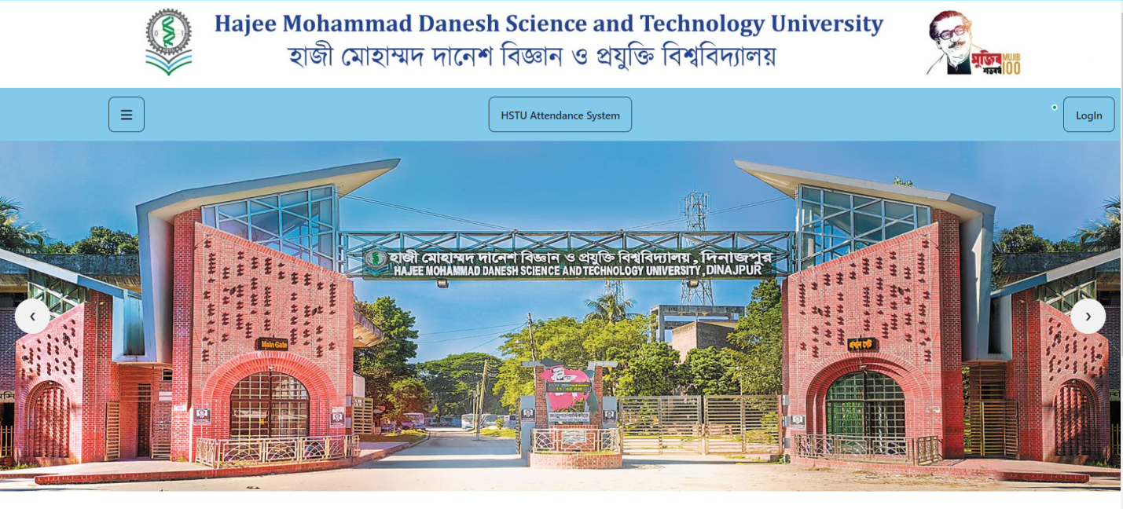

**2.Registration and Login Pages:**

Thispages are responsible for user registration and authentication. The registration page allows teachers to input their email, password. The login page requires users to enter their email and password to access the system.

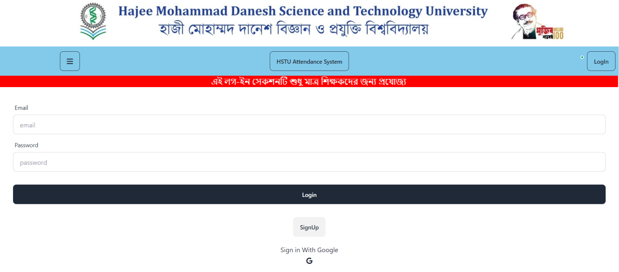

**3.CourseList for students:**

Students can only see the course list and cannot add or have the features to perform any actions.

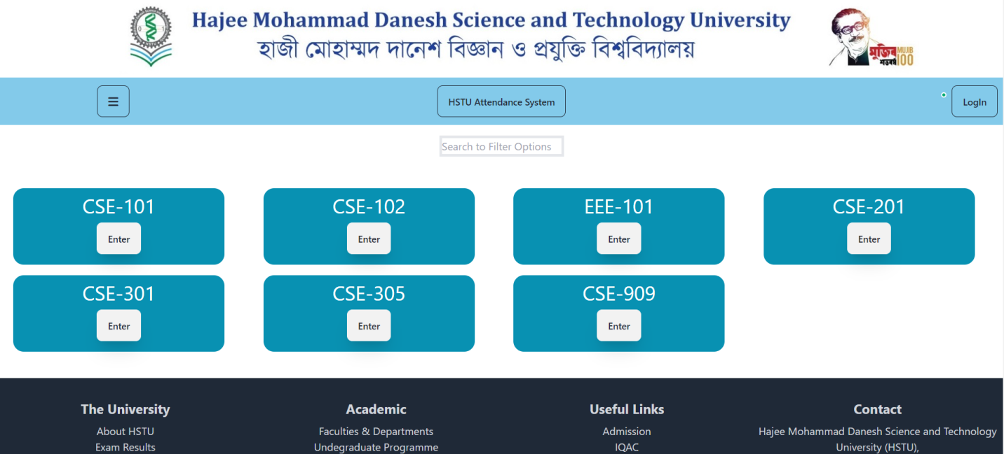

**4.ClassList for students:**

This page does not allow students to perform any actions it only shows the available classes of any particular course.

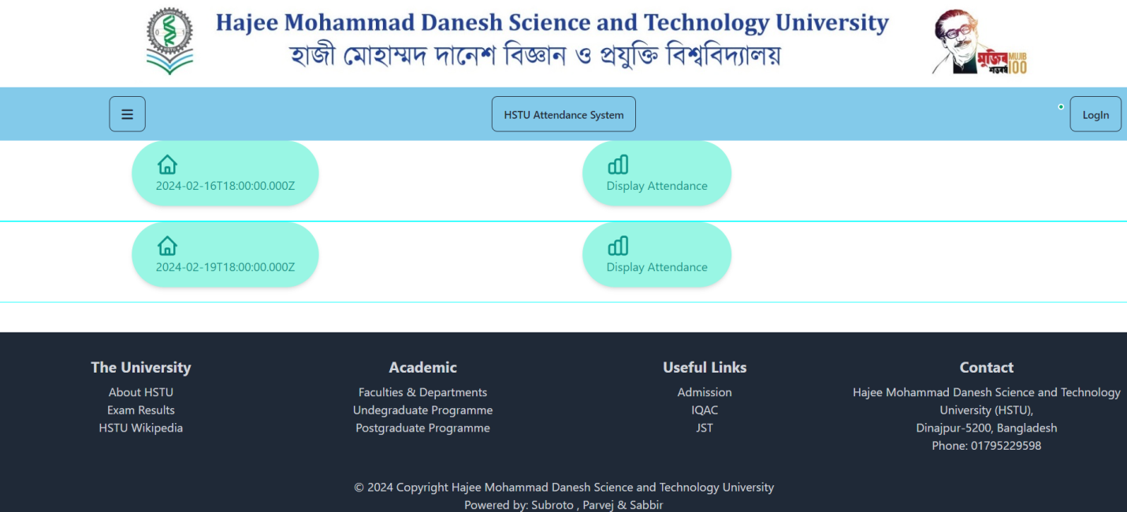

**5.Attendace list for students**:

It shows the student id of those who scanned their QR codes in any particular class.

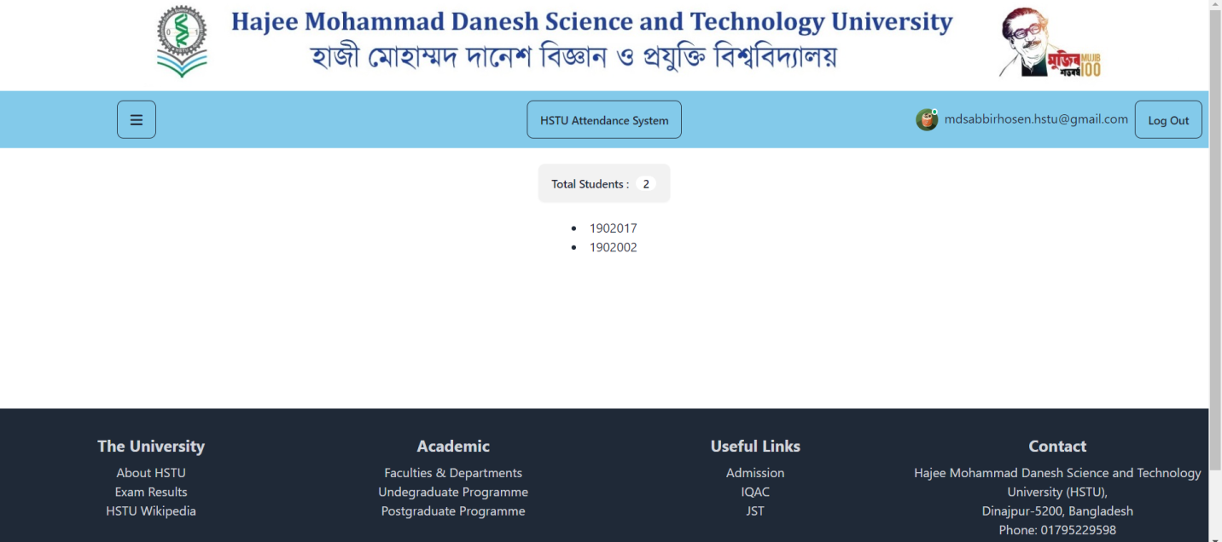

**6.Course list for Teacher:**

This page provides all the features to add courses filter out courses and also shows the list of courses for any specific teacher.The course created by another teacher cannot be accessed by another teacher.

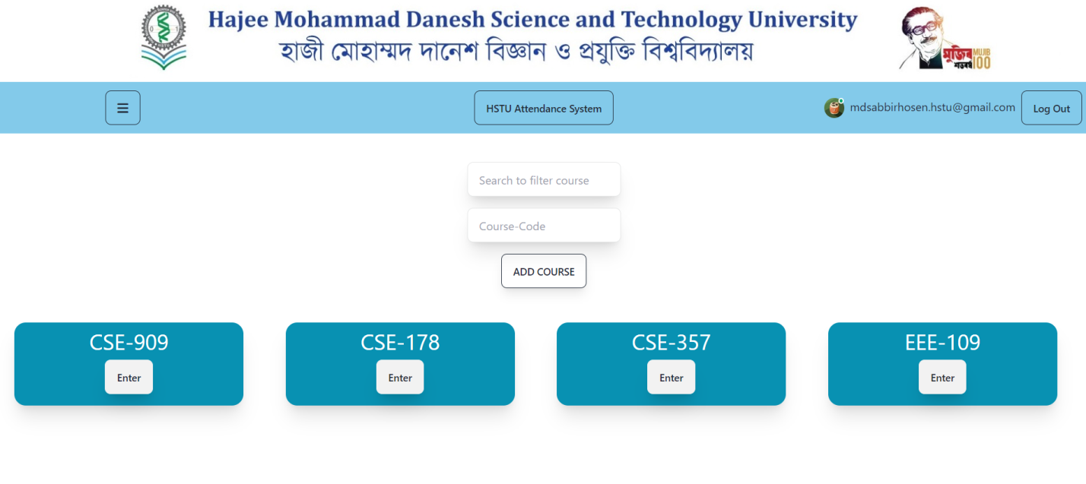

**7.Class list for Teacher:**

This page provides the feature to add classes with datepicker and shows the list of classes for particular course.Here another feature is:by giving any student id teacher can determine which classes a particular student has attended.

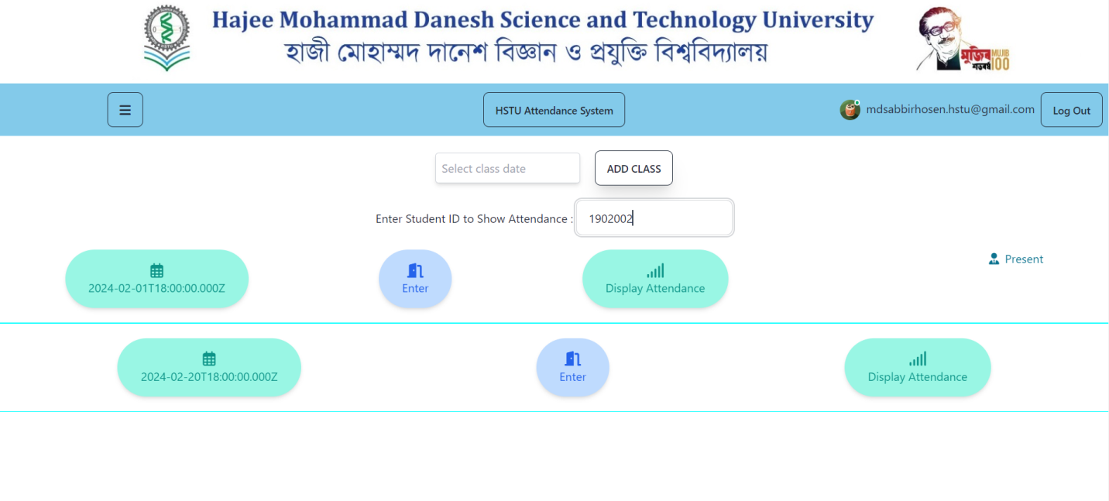

**8.QR scanner page for teacher:**

This page is only available for teachers.This page will allow teachers to start the qr scanner so that the students can scan their qr codes and give attendance.

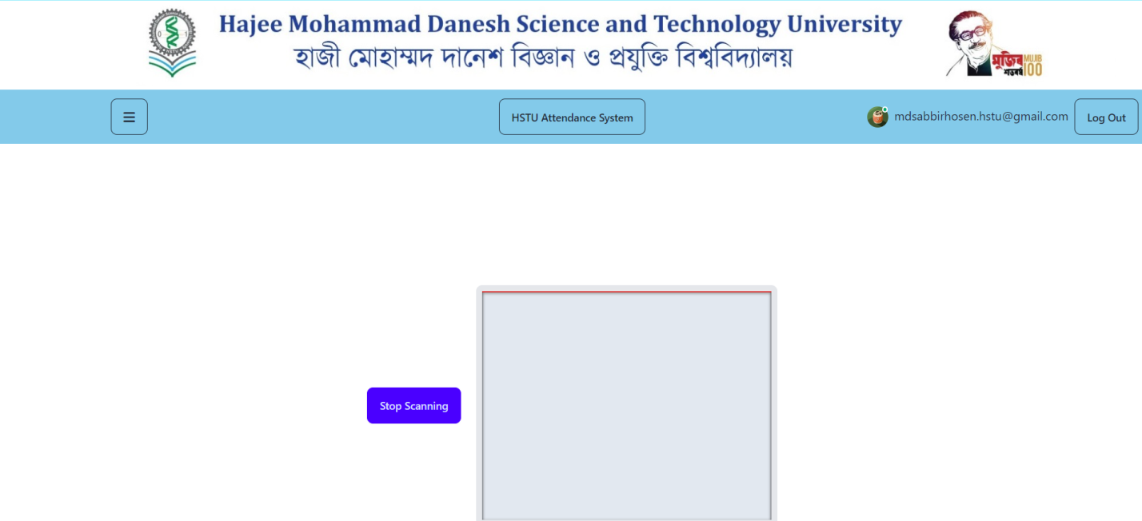

**9.Courses Collection of Mongodb:**

Mongodb is used to store data of added courses and the classes created inside every courses is stored as a objectId which is another collection used in the database.

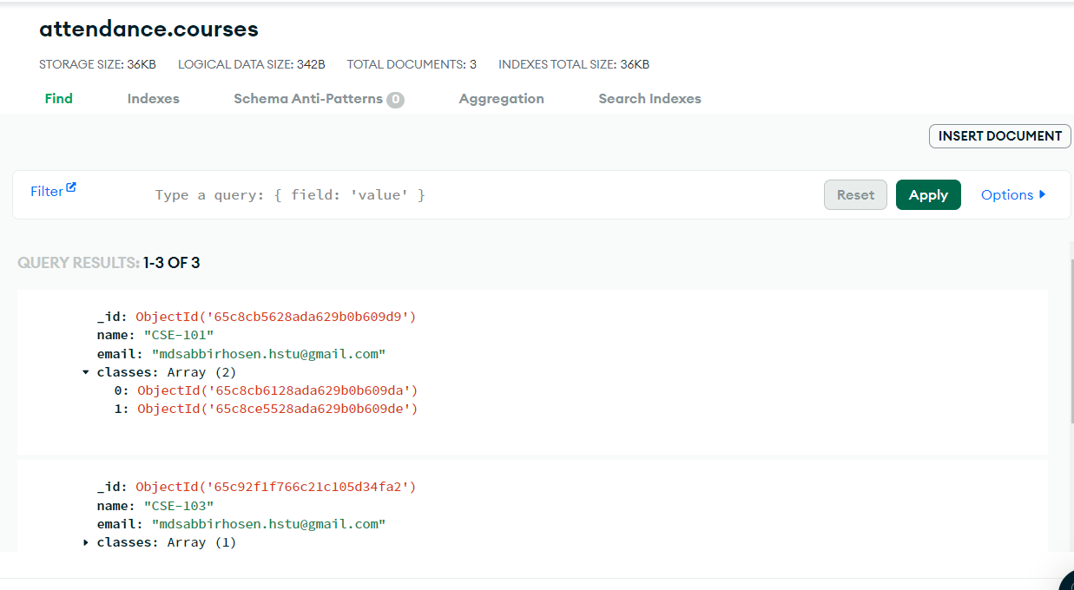

**10.Classes Collection of Mongodb:**

Classes collection is used to store the information of particular classes and inside these class collection for multiple students objectId is used as a reference to another collection named students.

In MongoDB, a collection is a grouping of MongoDB documents. MongoDB documents are similar to JSON objects and consist of key-value pairs. Each document in a collection can have its own unique structure, but they are typically related to each other in some way.

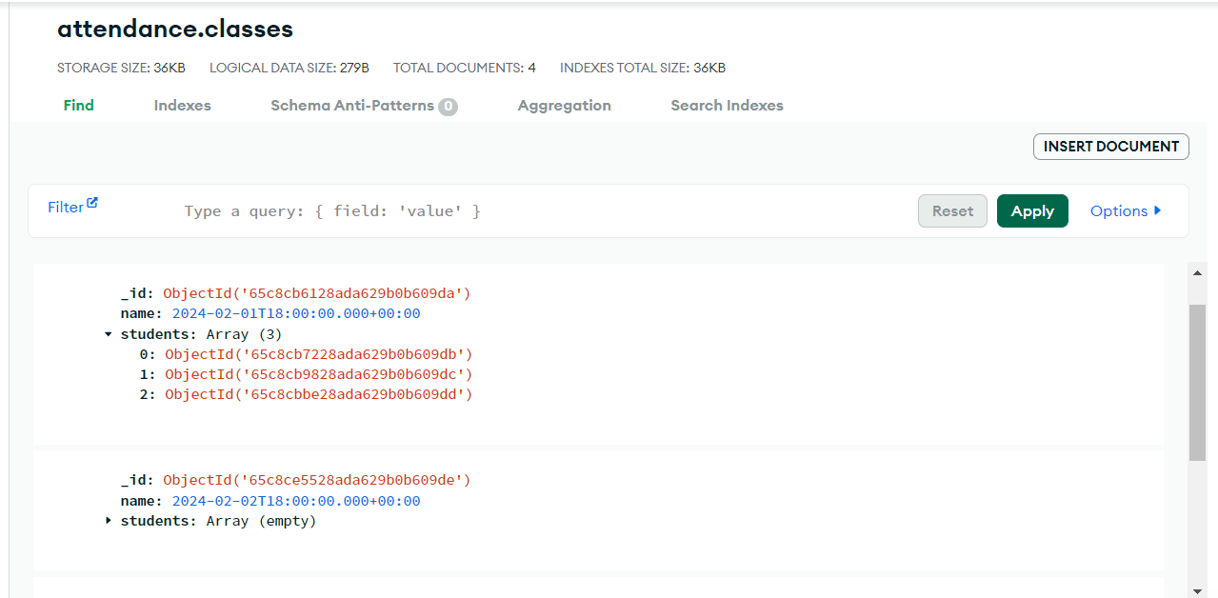

**11.Students collection of Mongodb:**

The student id that are scanned through qr scanner started by the teacher is stored here.

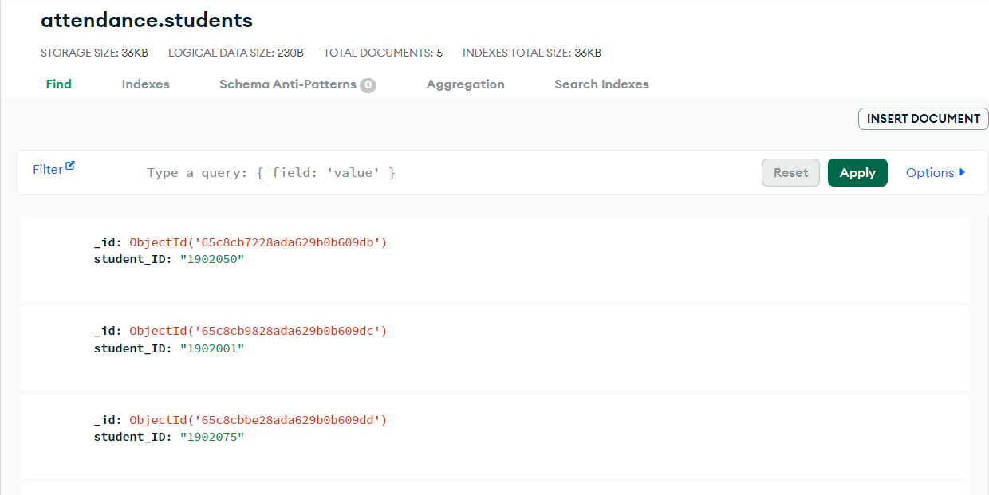

**CHAPTER 6**

**IMPLEMENTATION & TESTING**

**6.1 Database Setup:**

In the implementation phase, MongoDB Atlas was selected for its scalability and ease of integration. The MongoDB Atlas cluster was configured, and a connection string was obtained for the Node.js application. Database schema design focused on courses, classes, students, and attendance records. Indexes were optimized for query performance, and initial data migration populated sample data. Security measures, including network access restrictions and authentication mechanisms, were implemented to safeguard the MongoDB Atlas cluster. This setup provided a solid foundation for the implementation and testing of the attendance management system.

**6.2 Frontend Development:**

React.js was chosen for its component-based architecture, facilitating code reusability and modularity. Declarative rendering simplifies UI development, while React's virtual DOM ensures efficient updates. State management is handled using React's built-in features or external libraries like Redux. React Router enables seamless client-side routing, and styling can be done using CSS or CSS-in-JS libraries. Testing is supported by tools like Jest and React Testing Library. Once developed, the React application can be bundled and deployed using Webpack or similar tools to hosting platforms like Netlify or Vercel. This approach ensures a responsive and user-friendly interface for the attendance management system.

**6.3 Backend Development :**

Backend development focused on creating server-side logic and APIs to support the attendance management system. Node.js with Express.js was chosen for its scalability and asynchronous capabilities. MongoDB was integrated as the database using the Mongoose library for schema-based modeling. Authentication was implemented using JSON Web Tokens (JWT), and middleware handled request processing tasks such as parsing bodies and enforcing security headers. Robust error handling and logging were incorporated for debugging and monitoring. Unit tests were written using Jest and Supertest, and the backend was deployed to cloud hosting platforms like Heroku for production use. This approach ensured a reliable and scalable backend infrastructure for the attendance management system.

The implementation phase brings the system to life, converting design concepts into functional elements. It covers database setup and configuration, frontend development for a teacher-friendly interface, and backend development for handling teacher and student interactions and data management. Through this chapter, the "HSTU-Attendance system" application becomes a fully operational and interactive platform.

**6.4 Testing Implementation :**

This section, we discuss about the various testing applying in this project.

**6.4.1 Unit Testing :** In this section, the testing process at the module level is explained.

**1. Module Isolation:** Each module of the application is tested independently to verify its correctness and functionality.

**2. Input and Output Comparison:** Unit tests involve providing specific inputs to a module and comparing the actual outputs with the expected ones. This helps identify any discrepancies or errors.

**6.4.2 Integration Testing :** This section focuses on the testing process where multiple modules are combined and tested together.

**1. Module Interaction:** Integration testing ensures that different modules of the application work seamlessly when integrated. Scenarios involving interactions between modules are tested.

**2. End-to-End Scenarios:** Common scenarios like user registration, login, adding courses,classes to the application, managing the attendance information, and qr scanning are tested to ensure smooth end-to-end functionality.

**6.4.3 User Testing :** The phase of involving real users in testing the application is explained here. 1. Beta Testing: Real users interact with the application in a real-world environment. They provide feedback based on their experience, identifying usability issues, bugs, or unexpected behaviour.

**2. Feedback Collection:** Users' feedback is collected and analysed to understand their perspectives, pain points, and suggestions for improvement.

**3. Issue Identification:** During user testing, issues that may not have been identified during development are discovered. These issues are recorded for further investigation and resolution.

The testing and validation phase ensures that the application functions as intended and meets teacher expectations. Unit testing guarantees the correctness of individual components, integration testing ensures seamless module interactions, and user testing validates real-world user experiences. The feedback received during user testing is valuable for refining and enhancing the application before its final release.

**CHAPTER 7**

**CONCLUSION AND FUTURE SCOPE**

**7.1 Achievements :**

**1. Efficient Attendance Management:**

* QR code scanning streamlines attendance tracking, reducing errors and saving class time.

**2. Simplified Course Management:**

* Teachers easily add courses and schedule multiple classes, allowing more focus on teaching.

**3. Data Accuracy Improvement:**

* Real-time attendance recording ensures accurate data for insights into student participation.

**4. Transparency and Accountability:**

* Comprehensive attendance reports foster accountability among students and aid educators in addressing attendance patterns.

**5. Student Empowerment:**

QR code scanning empowers students to monitor attendance, fostering a proactive approach to academic success.

**6. Technology Adoption:**

Utilization of modern technologies showcases the institution's commitment to innovation in education.

**7. Scalability and Flexibility:**

The system's architecture allows easy expansion to accommodate future growth and changing needs.

**8. Positive Teaching and Learning Impact:**

The project enhances teaching efficiency and learning experiences, contributing to a more effective educational environment.

**7.2 Future Enhancements :**

This section discusses potential improvements and additions that can be made to the application in the future.

**1. Biometric Authentication:**

* Introduce fingerprint or facial recognition for secure attendance tracking.

**2. Mobile Application Integration:**

* Develop a mobile app for on-the-go access to attendance records and notifications.

**3. Machine Learning Attendance Prediction:**

* Predict attendance patterns using machine learning algorithms.

**4. Geolocation-based Attendance:**

* Track attendance based on students' physical presence using geolocation.

**5. Automated Attendance Reminders:**

* Send automated reminders to reduce absenteeism.

**6. Interactive Attendance Analytics:**

* Provide visualizations for deeper attendance insights.

**7. Integration with Learning Management Systems (LMS):**

* Seamlessly connect with existing LMS platforms for enhanced user experience.

**8. Student Engagement Metrics:**

* Track participation and contributions beyond attendance.

**9. Integration with Student Information Systems (SIS):**

* Sync enrollment data with SIS for streamlined administration.

**10. Voice-based Attendance Marking:**

* Allow attendance marking through voice recognition technology.

**REFERENCE**

[1] React Router Documentation [Online],Available: <https://reactrouter.com/en/main>

[2] NodeJs Mongodb Documentation[Online], Available: <https://www.mongodb.com/docs/drivers/node/current/>

[3] Tailwind Css Documentation [Online], Available: <https://tailwindcss.com/docs/>

[4] Abraham Silberschatz, Henry F. Korth and S. Sudarshan, Database System concepts,7th edition. New York: McGraw-Hill Education, 2020.

# [5] Fadi almasalha (2014). “A Students Attendance System Using QR Code”. International Journal of Advanced Computer Science and Applications

, DOI:[10.14569/IJACSA.2014.050310](http://dx.doi.org/10.14569/IJACSA.2014.050310) https://www.researchgate.net/publication/275605455_A_Students_Attendance_System_Using_QR_Code